St. Malachy’s College,
Belfast

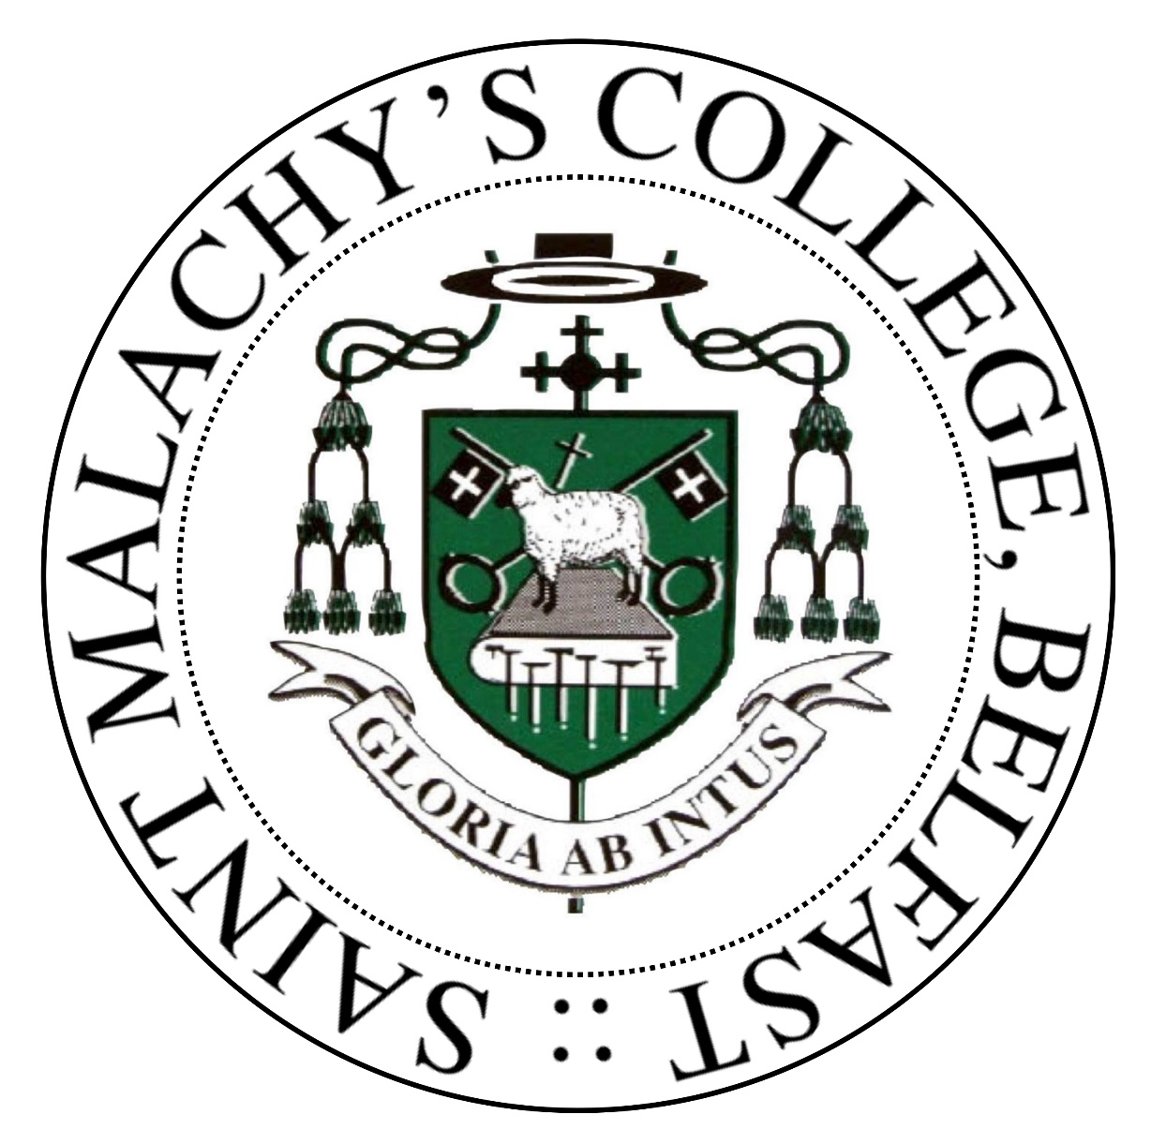

- Examination Results 2022-23
- Curriculum Details 2023-24
Examinations

The College continues to produce personal bests in GCSE, AS and A2 Examination results. Prior to the pandemic, the Education Training Inspectorate commended the College on its academic outcomes. Having emerged from the past few challenging Covid years when schools and colleges were tasked with assigning grades to all students, and since 2022, all schools have returned actual examinations. In 2023 we can report that the College has again produced an excellent set of results, with the majority of headline figures representing an all-time best!

GCSE
All year 12 students are entered for GCSE examinations with the following examination boards:
- Computing - WJEC
- All other subjects - CCEA
Category
Number of students in Year 12 | 155
Number of Students level 5 SEN | 6
% entered for 5 or more GCSEs | 100%
% achieving 5 or more GCSEs | 99.4%
% achieving 5 or more GCSEs including English & Maths | 99.4%
% entered for 7 or more GCSEs | 100%
% achieving 7 or more GCSEs | 94.2%
% achieving 7 or more GCSEs including English & Maths | 94.2%

GCSE Results by Subject

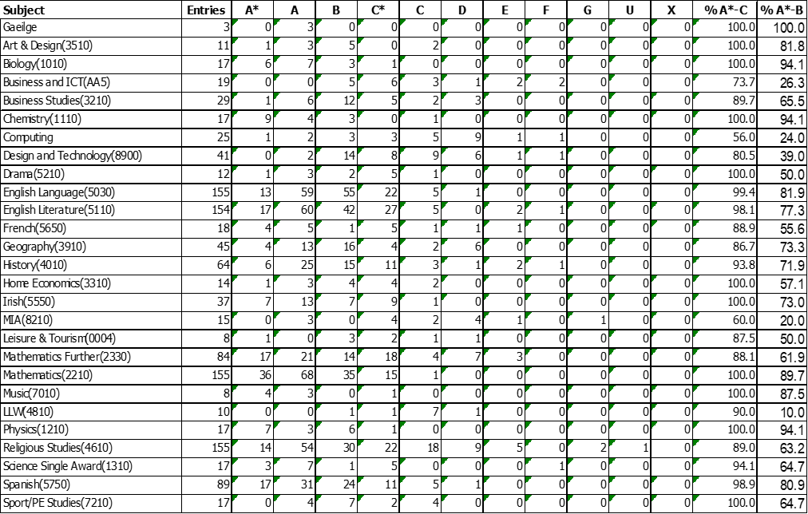

DA Sc | Entries | A*A* | A*A | AA | AB | BB | BC* | C*C* | C*C | CC | CD | U | % A*-C | % A*-B
 | 121 | 17 | 10 | 23 | 18 | 19 | 9 | 9 | 5 | 3 | 7 | 1 | 96.3 | 75.6

A Level
Category
Number of Students in Year 14 ( Exam Cohort) | 111
Number of students level 5 SEN | 7
% achieving 3 or more A level passes grades A*-C | 88.3%
% achieving 3 or more A Level passes grades A*-E | 98.2.%

- 88.3% of students achieved Grades A*- C in 3 or more subjects
- 56.8 % of students achieved Grades A*- B in 3 or more subjects

A Level Results by Subject

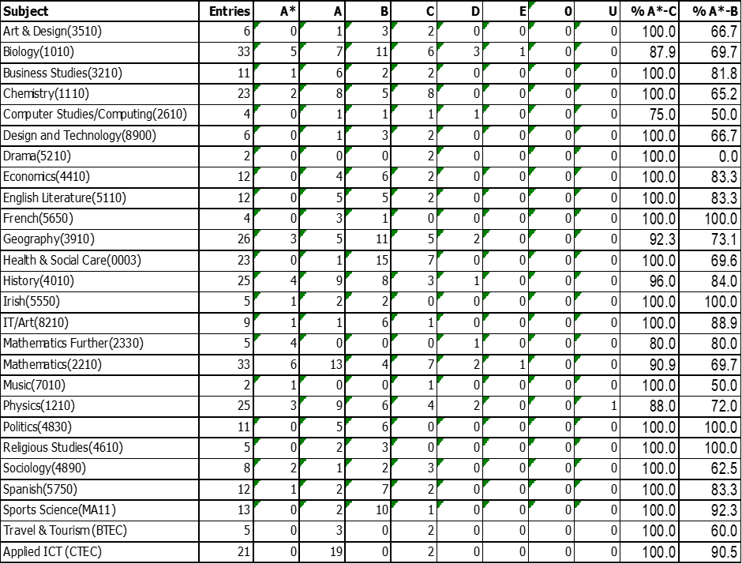

Performance in Public Examinations: 2021-22 – 2022-23
 | 2021-22 | 2022-23
 | School | School
% achieving 5+ GCSEs at Grade A*-C | 98.16% | 99.4%
% achieving 7+ GCSEs at Grade A*-C | 95.71% | 94.2%
% achieving 3 + A Levels at Grades A*-C | 83.3% | 88.3%
% achieving 2 A Levels at Grades A*-E | 100% | 100%

Destination of Leavers in 2022-23
Year Group | No. of Pupils in Year Group | % to Higher Education | % to Further Education | % to another school | % in Employment | % Other
14 | 116 | 81.0% | 2.6% | 0% | 11.2% | 5.2%

Curriculum Details 2023-24

St. Malachy's, as a Diocesan College, aims to create a Catholic ethos in which students flourish and develop all their talents. The school therefore begins from the principle that its curriculum, which is seen as the total range of learning experiences and activities provided by the College, including its pastoral provision, is intentionally directed to the growth of the whole person. Belief in a God of love, justice and forgiveness is seen as being essential to this process.

The College motto Gloria ab Intus (Glory from within) reflects our conviction that education is not merely concerned with the imparting of information but is also about helping young people to mature as individuals, developing in them a strong emotional resilience in preparation for life beyond the College. The College seeks to preserve its traditions of spirituality and learning so that all pupils and staff can experience continuity in achievement and further their own spiritual, educational and personal growth in a pleasant, interesting and stimulating environment.

SUMMARY OF CURRICULUM PROVISION

KEY STAGE 3

In years 8 and 9 all pupils follow a similar curriculum, which includes a total of sixteen subjects including discrete provision for Learning for Life and Work (LLW). Elements of LLW are also infused across the learning areas, along with opportunities for the development and assessment of the cross-curricular skills (Communication, Digital Skills, Using Maths).

Art & Design Science
Physical Education Technology
Drama Home Economics
Music Mathematics
English Geography
2 of French/Irish/Spanish History
Religious Education Digital Skills & ICT
LLW

LLW includes the delivery of:
- Personal Development
- Citizenship
- Employability

In year 10 extra time is given to Employability in preparation for GCSE and important career choices. In addition, the three sciences are delivered by specialist teachers and taught as three individual strands
KEY STAGE 4: Choice of subjects at GCSE

Core Subjects:
- English Language
- English Literature
- Mathematics
- Religious Studies
Sciences:
- Single Award Science
- Double Award Science
- Triple Award Science (Physics, Chemistry and Biology)
Languages:
- French
- Gaeilge
- Irish
- Spanish
Options:
- Art and Design
- Business and Communication Studies (BACS)
- Business Studies
- Computer Studies
- Drama
- Further Mathematics
- Geography
- History
- Home Economics
- LLW
- Leisure and Tourism
- Moving Image Arts
- Music
- Physical Education
- Technology and Design

KEY STAGE 5: Choice of subjects at A2 and AS level

The Sixth Form Curriculum aims to build upon the foundations laid in KS4.

The College tries to accommodate any combination of subjects. Pupils normally study three subjects for AS, pupils with a strong GCSE performance are encouraged to study a fourth subject at GCE AS-level. Most students take three subjects through to A2 level but some may continue to study four.

The following subjects are currently being offered at AS-level or A2-level: (2023-24)

Applied ICT (CTEC) Art & Design Biology
Business Studies Chemistry Computing/ SSD
Design & Technology Drama Economics
English Literature French Further Mathematics
Financial Capability Geography Health & Social Care
History Home Economics Irish
Mathematics Moving Image Arts Music
Physical Education Physics Politics
Religious Studies Sociology Spanish
Sport (BTEC) Travel & Tourism (BTEC)

Some of these subjects are offered through collaboration with other schools from within the North Belfast Area Learning Community.

All pupils are required to supplement their A-level studies by taking additional courses in Religious Education (except for students taking A-level Religious Studies) and Careers Education. Students are encouraged to include time for Physical Education (personal fitness training) as well as partaking in the Enrichment programme and Voluntary Service programme. These additional courses are offered to broaden the educational experience of the pupils by providing access to knowledge, understanding and skills in a greater range of curricular areas. All students also have a weekly tutorial period.

