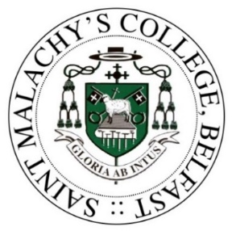
ST MALACHY’S COLLEGE
The Board of Governors of the College invites applications for the following posts:
Accounts Officer/Assistant PA to Principal
To assist in the effective and efficient operation of the College’s financial administration and to provide a confidential and professional administrative service to the Principal.
Essential Criteria: 5 GCSE's/O Levels including English and Maths (grades A to C) or equivalent qualifications and at least one year’s relevant work experience in an office environment. Fully conversant with Microsoft Office applications and possess proficient IT skills.
Desirable Criteria: Preference may be given to those applications that are educated to Degree level, and/or have at least three months accounts or secretarial experience.
Salary: NJC Scale Points 5 to 8 (£19,650 to £20,852 per annum).
Hours of work: Monday to Thursday: 8.00am – 4.15pm, Fridays: 8.00am to 3.45pm. Summertime working hours: Monday to Thursday: 8.30am – 3.45pm, Fridays: 8.30am to 2.45pm

Part-time Cleaners
Undertake, as part of a team, the cleaning of any area within the College premises, designated by the Bursar or Cleaner Supervisor, to enable those premises to be kept in a clean and hygienic condition.
Desirable Criteria: Preference may be given to applicants with previous cleaning experience in an industrial/commercial environment.
Hours & Pay: 16hrs 35mins per week starting at 3.30pm Monday to Friday during term-time and 9.30am or 12.30pm during school holidays. £9.8639 per hour.

Criteria may be enhanced on all posts for short-listing purposes. Further information and application forms are available directly at the College’s reception, to download from the College website at http://www.stmalachyscollege.com or by post from The Monitoring Officer, 36 Antrim Road, Belfast BT15 2AE. Closing date for receipt of applications is Thursday 27th October 2022 at 3.30pm
.

